 |  |  |  | Installation guideline on Windows
 |  | https://www.linkedin.com/in/pravesh-jha-33013155
 |  | Pravesh28@gmail.com

Prerequisite Software
- Node JS
(Reference: https://nodejs.org/en/download/)
- Web server for Chrome Extension
(Reference: https://chrome.google.com/webstore/detail/web-server-for-chrome/ofhbbkphhbklhfoeikjpcbhemlocgigb?hl=en)
- URL Rewrite Extension
(Reference: https://www.iis.net/downloads/microsoft/url-rewrite)

Host Automation Studio on IIS Step by Step:

- Download Automation studio from github.
- Create any folder on your device and place the downloaded folder inside it. Over here I created a folder (AutomationStudio) in My C drive and place the download folder inside it.
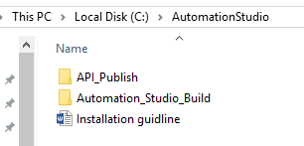
- Launch Web server for chrome.
- Select Reports folder (C:\AutomationStudio\Automation_Studio_Build\Automation_Resources\Reports) from Web Server Chrome.

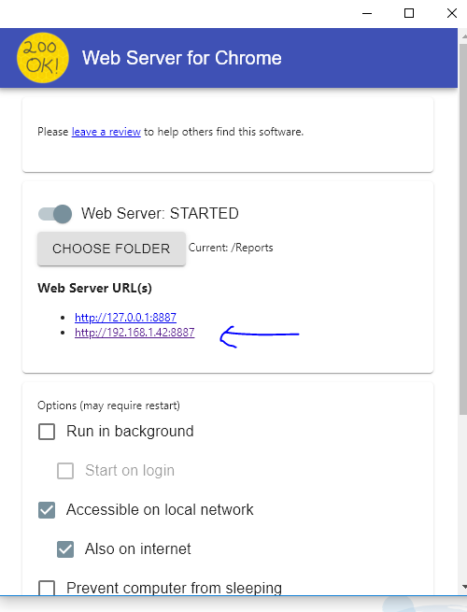
- Note down Web Server URL (IP)
- Open Web.config file from C:\AutomationStudio\API_Publish folder.
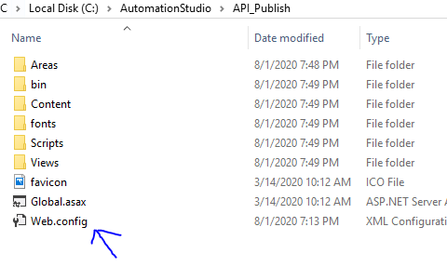
- Update RectjsDir key with value : (C:\AutomationStudio\Automation_Studio_Build\Automation_Resources\)
- Update ReportPublishURL key with value (Web server URL)
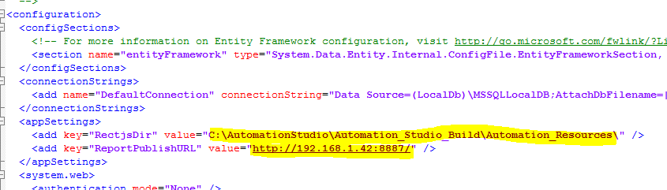

- Add new Site in IIS (select any name automationstudioapi, port number 49957 and select set Physical path =C:\AutomationStudio\API_Publish

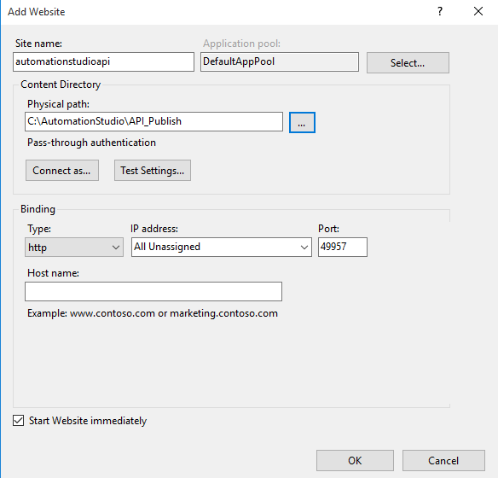

- Note down API URI : (http://MachineIPAdrress:49957/)
- Open ServerAddress.js file from C:\AutomationStudio\Automation_Studio_Build\build folder.
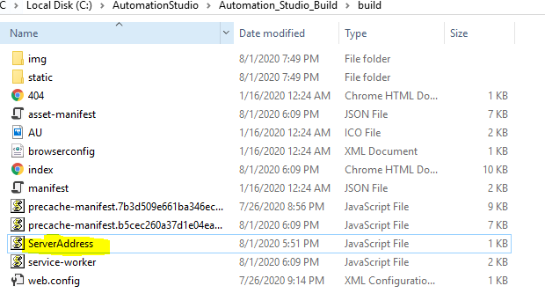
- Update APIURL : http://MachineIPAdrress:49957/api/ and ReportURL : IP (web server for chrome)
- Add new site from IIS (sitename=Automationstudio,Physicalpath= C:\AutomationStudio\Automation_Studio_Build\build , Port Number =3001)

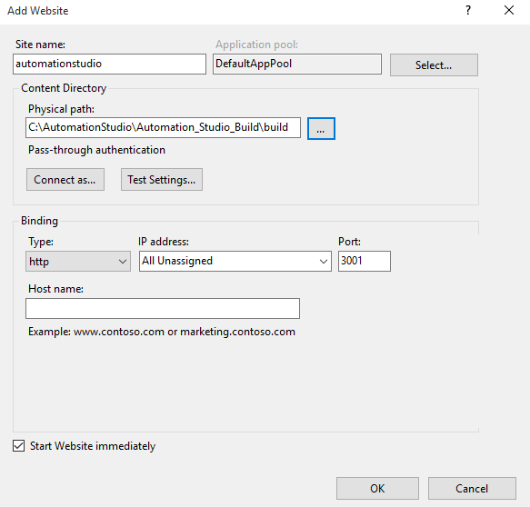

- Browse your application using IP or local host

Browser driver set up:

- Check browser version on your machine.
- Download Respective chromedriver and geckodriver
(Reference: https://chromedriver.chromium.org/)
(Reference: https://github.com/mozilla/geckodriver/releases)

- Save this browser driver under \ Automation_Studio_Build\Automation_Resources\SeleniumDLL folder.

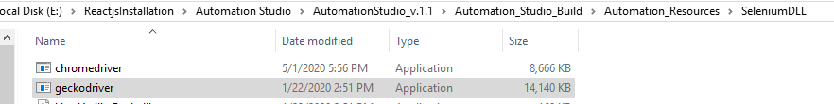

Selenium Grid Set Up:
- Open jsonHubRegister.bat file in Notepad from path \Automation_Studio_Build\Automation_Resources\Selenium_Grid_Configuration
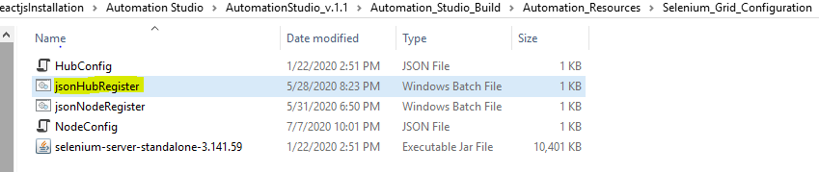
- Update Home Path : home path will be absolute path
Downloaded Automation studio path\Automation_Studio_Build\Automation_Resources\Selenium_Grid_Configuration

- Open jsonNodeRegister.bat file in Notepad from path
\Automation_Studio_Build\Automation_Resources\Selenium_Grid_Configuration

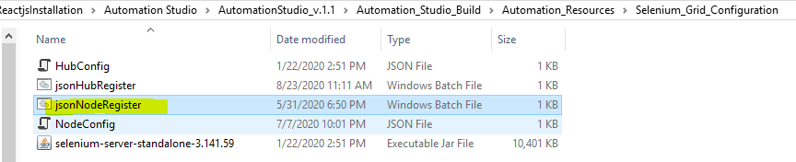

- Update HomePath and MiscPath
Home Path = Your Parent folder +Automation_Studio_Build\Automation_Resources\Selenium_Grid_Configuration\
MiscPath= Your Parent folder+\Automation_Studio_Build\Automation_Resources\SeleniumDLL

